AI Assisted Coding -LAB TEST

Enrol No:2503A52L17

Q1. AI-Assisted Code Optimization
● Task:
Write a prompt to generate a Python program for sorting a list of numbers using AI tools.
● Prompt:
To generate a Python program for sorting a list of numbers using AI tools.
● Code:
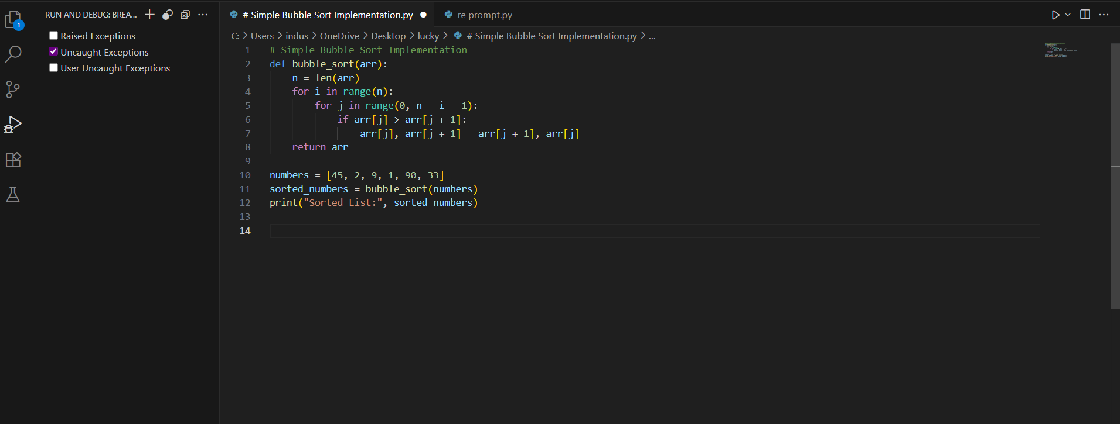

● Then re-prompt the AI to optimize the code for better performance (time complexity).
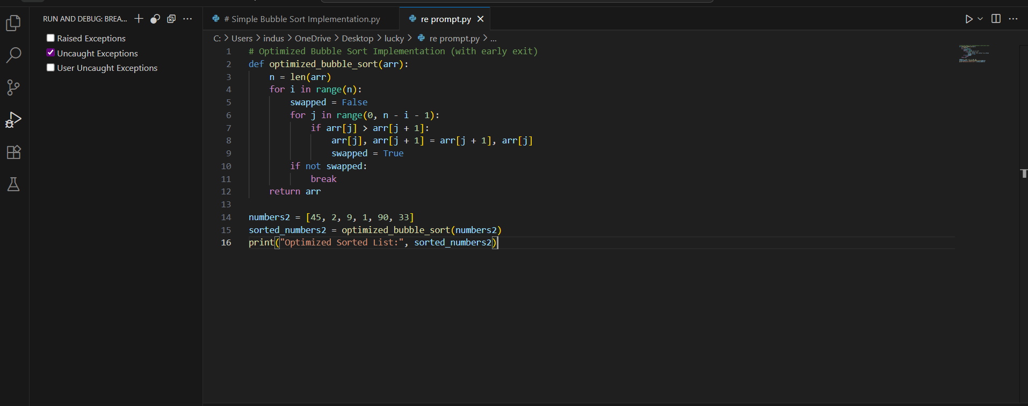

● Output:
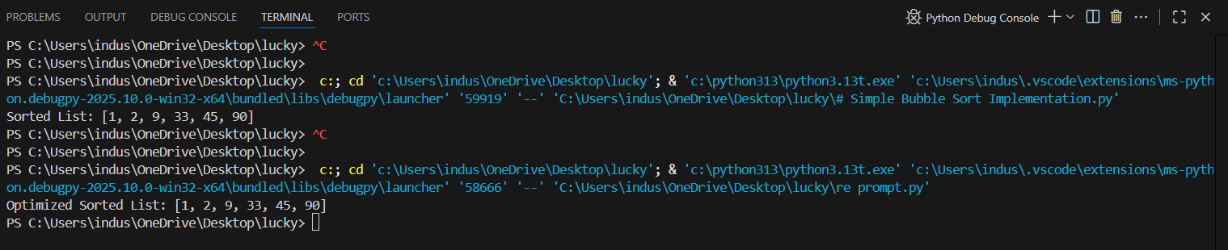
● Observation:
- Swap Detection
- Case time
- Performance
- Logic

Q2. Multi-Stage Code Generation
● Task:
Ask AI to generate a Python program for Fibonacci series.
● Prompt:
To generate a Python program for Fibonacci series.

● Code:
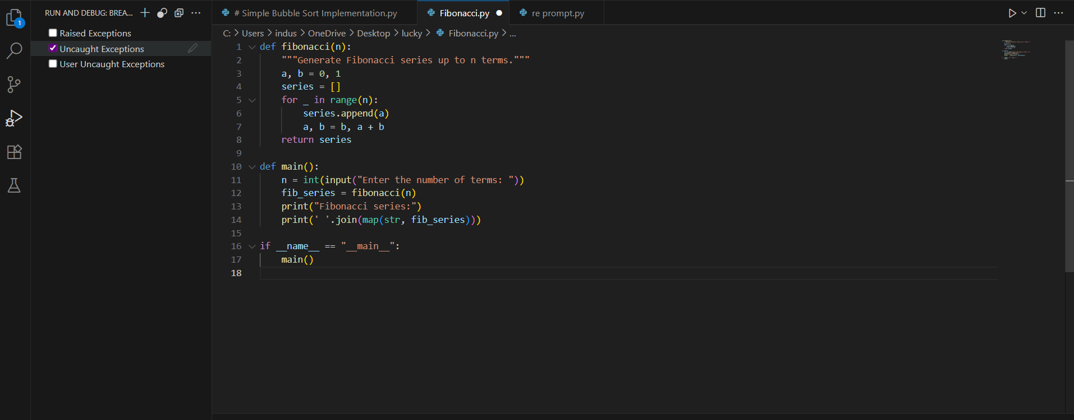

● re-prompt AI to modify the program so that it:
1. Accepts user input (n terms).
2. Uses functions to improve modularity
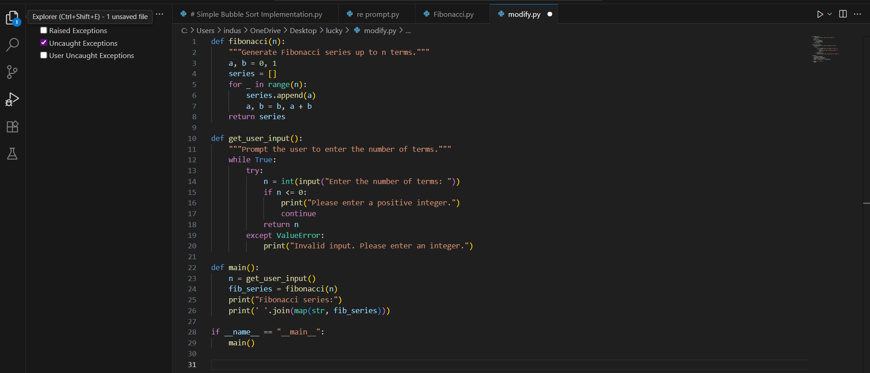

● Output:
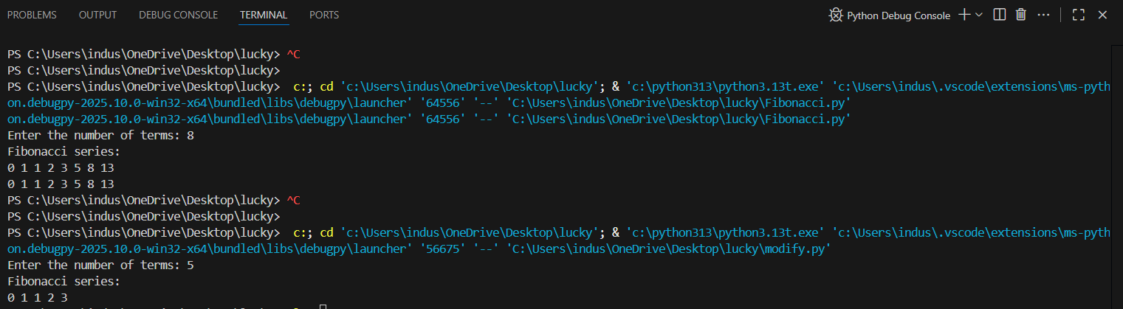

● Observation:
- Function-based Modularity
- Input Validation
- Clean Output
- Scalability & Extensibility

